Hotflix

# 

Online Movie Booking System

( USER GUIDE )

# PROJECT GROUP MEMBERS

|  |  |
| --- | --- |
| STUDENT’S ID | STUDENT NAME |
| SStudent1555602 | **Abdul Haseeb Qazi** |
| Student1544631 | **Syed Yousuf Hussain** |
| Student1544538 | **Muhammad Awias Miskeen** |
| Student1521685 | **Muhammad Saad** |

**CURRICULUM BATCH**

**7062 2312F**

**FACULTY**

**“MS. DAANIA SHABIH”**

**HOME PAGE**

**When user open our website, they will see this user-friendly home page.**

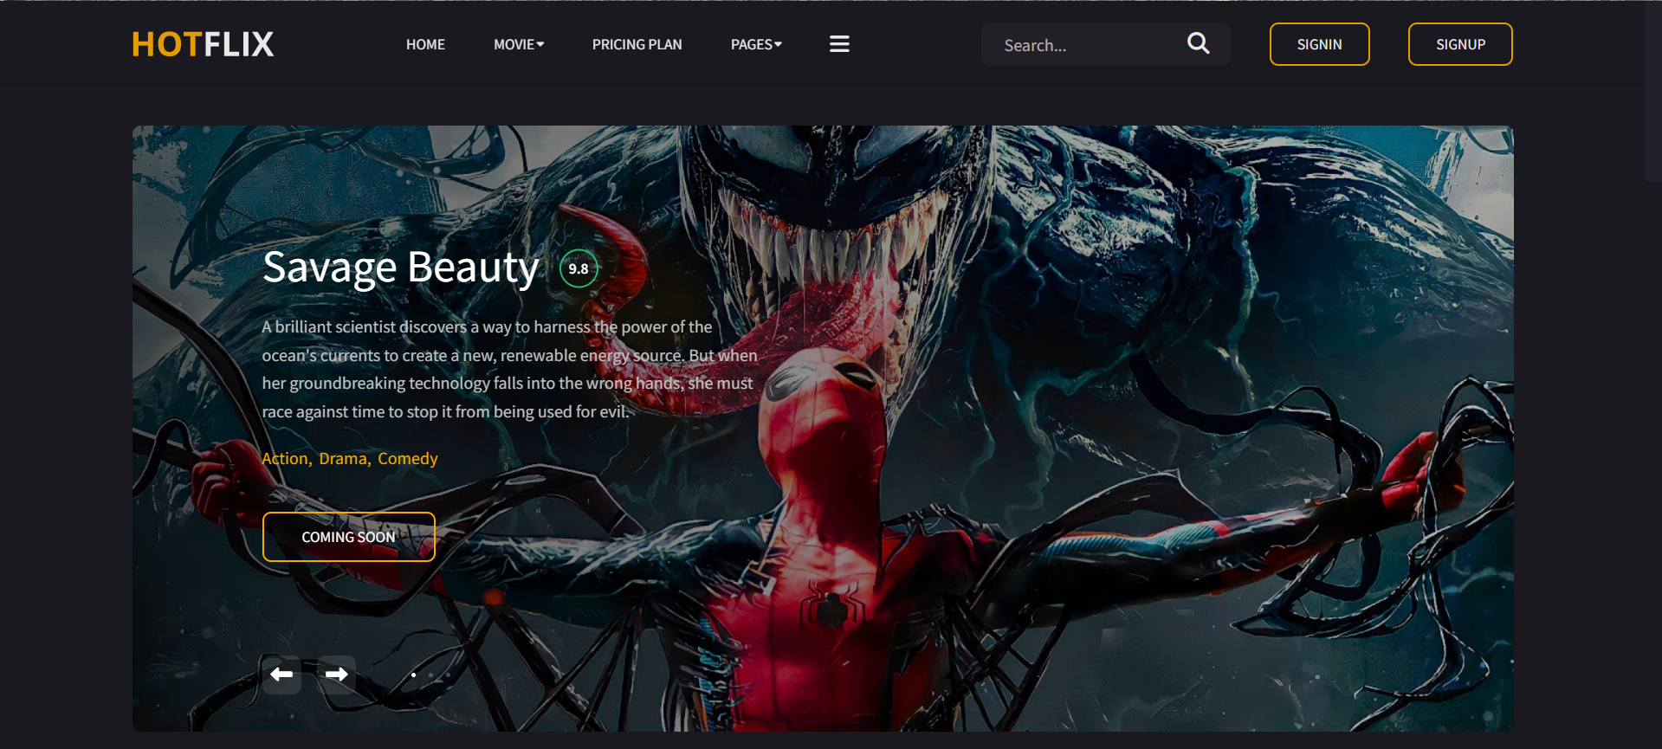

**TRAILER**

**Visitor can watch trending movie trailers.**

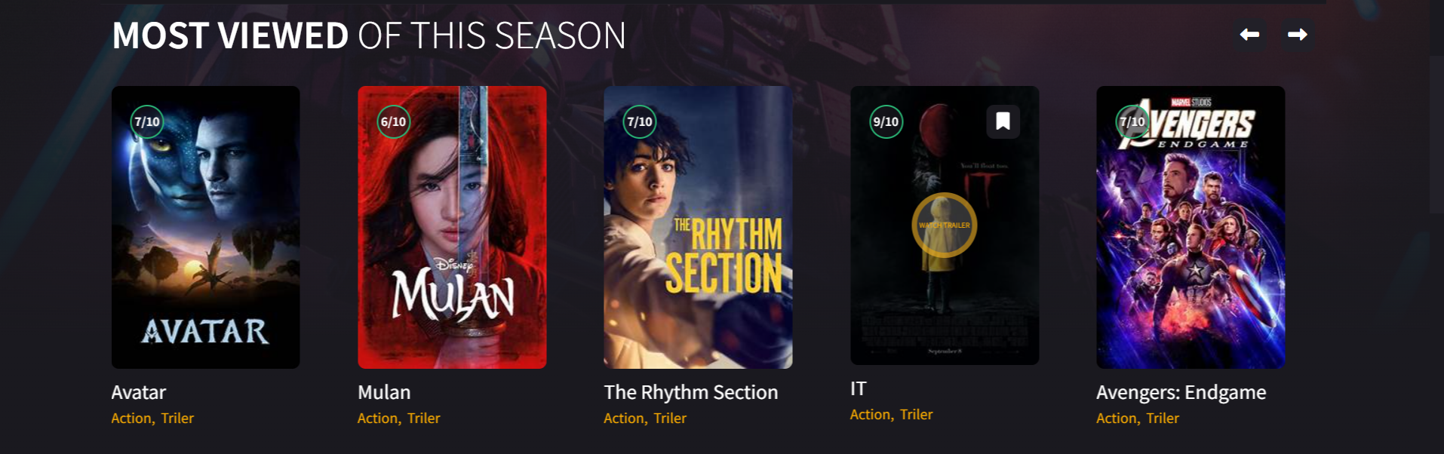

**TRAILER 2**

**Visitor can watch trending movie trailers.**

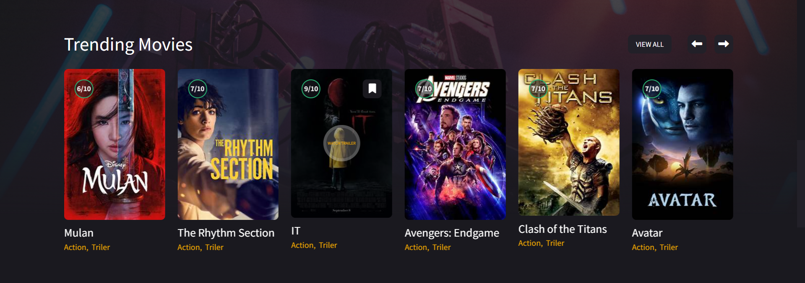

**MOVIE**

**Here. Visitor can see upcoming movies and book their tickets.**

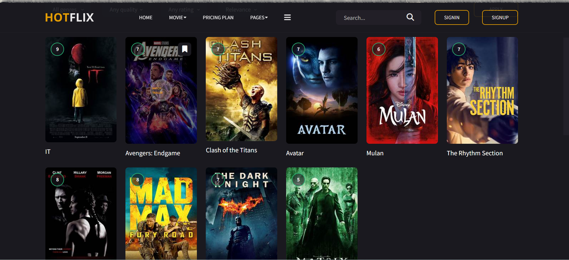

**FAMOUS ACTOR**

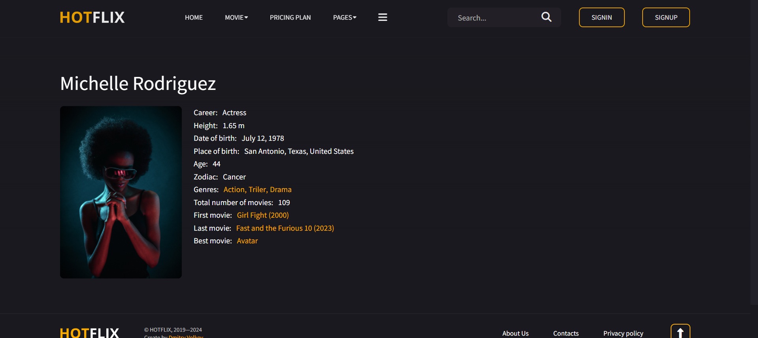

**COMING SOON MOVIES**

**Here, visitor can find upcoming movies and premiere**

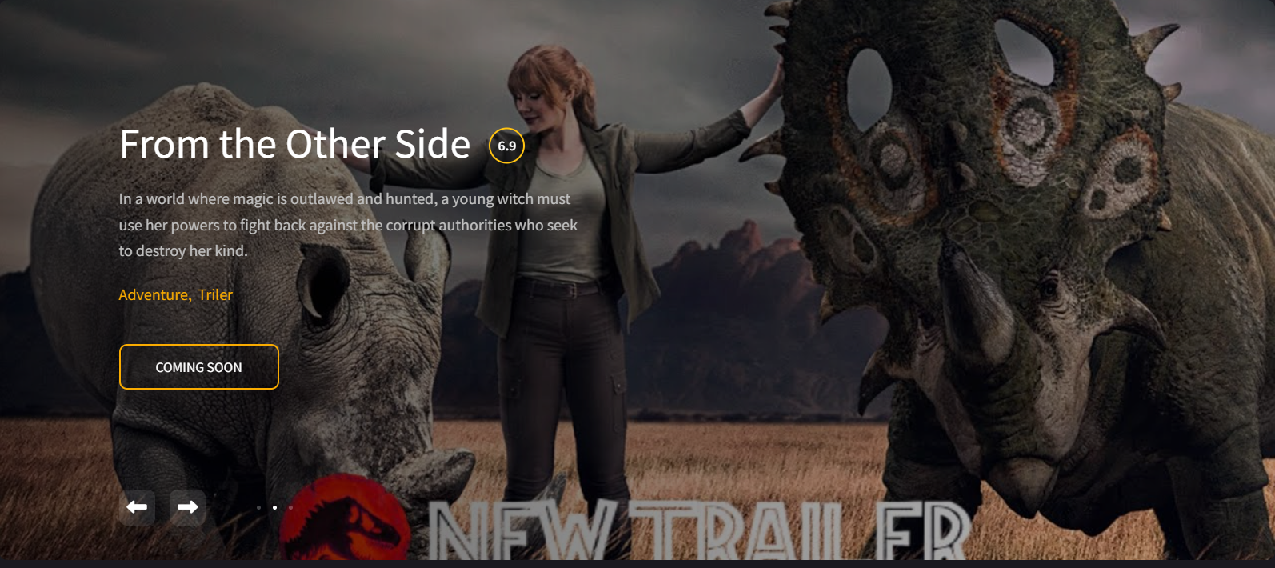

**SIGNIN**

**Visitor can SIGNIN and register themselves**

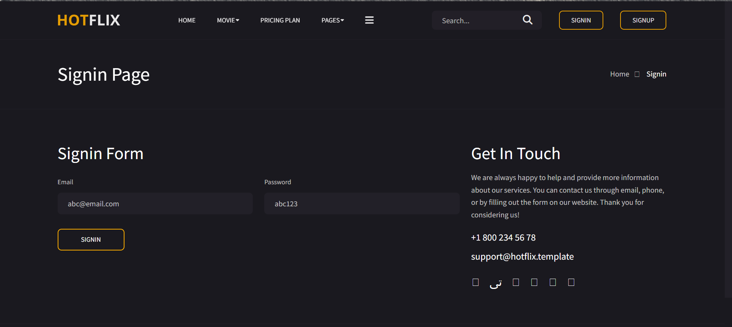

**SIGNUP**

**Visitor can SIGNUP or register themselves**

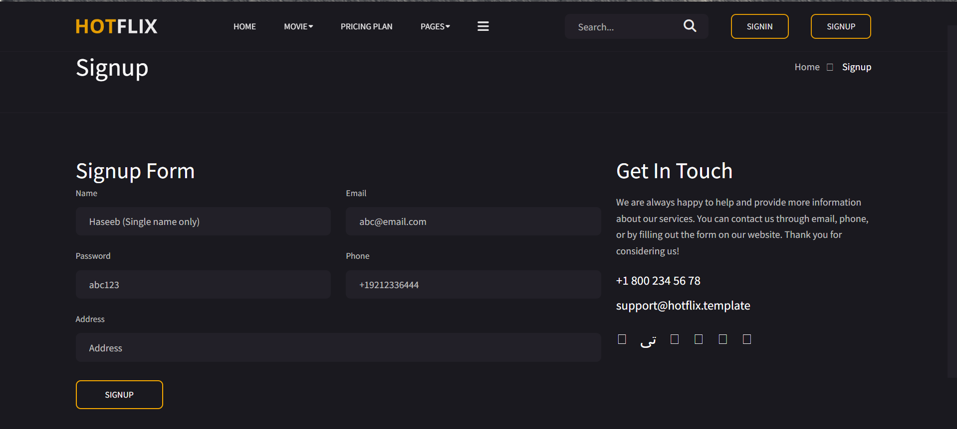

**FOOTER**

**In the end of the website visitor can see this footer which have some links**



**WATCH MOVIE DESCRIPTION**

**In this user can see movie description**

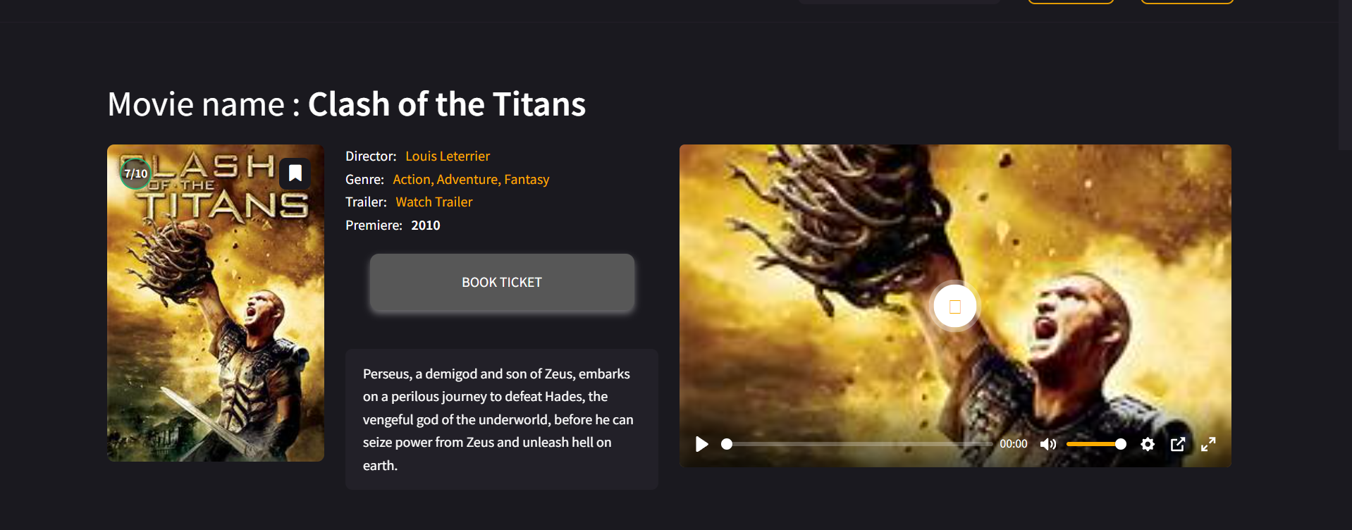

**BOOK TICKET FORM**

**User Cn book their ticket**

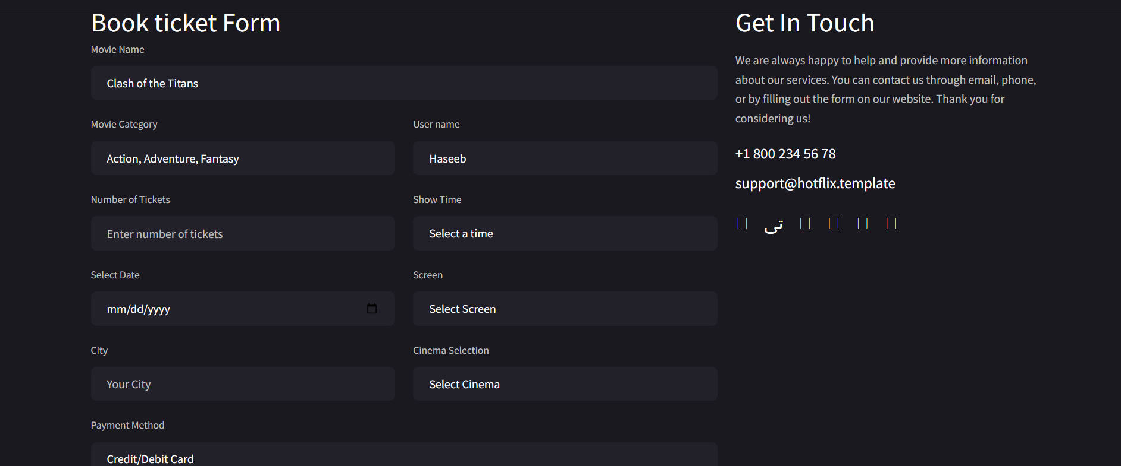

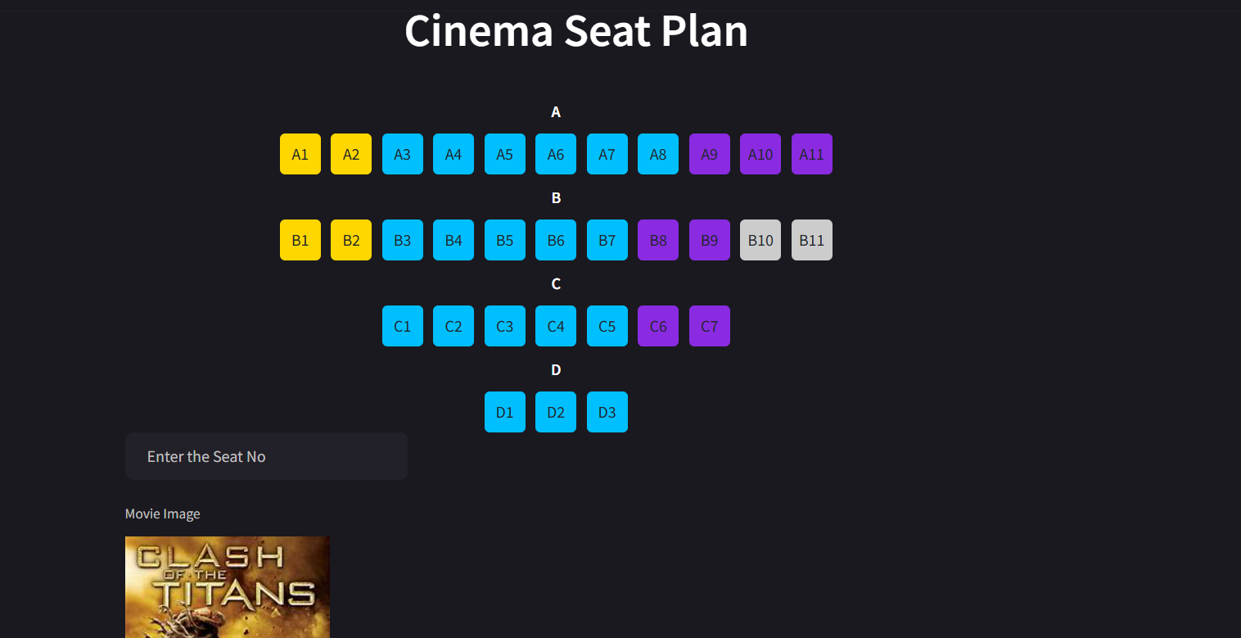

**MOVIE TICKET DETAILS**

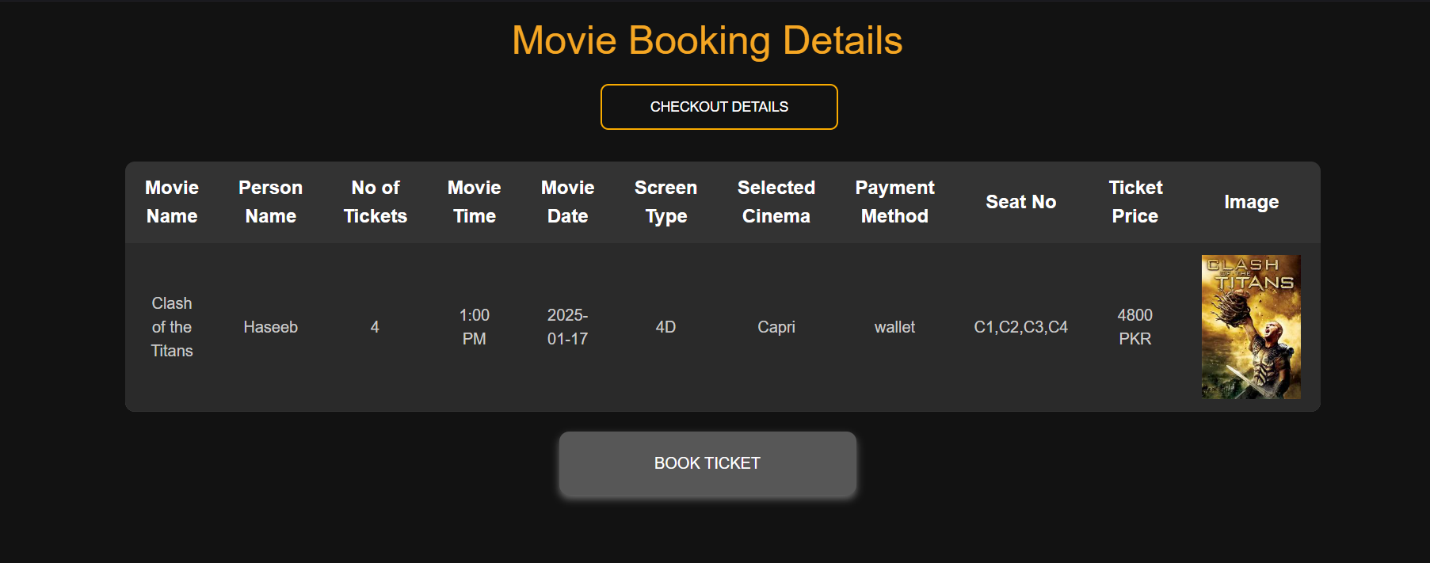

**TICKET**

